1. Cookies that could be called good cookies are #2, #5, #9.

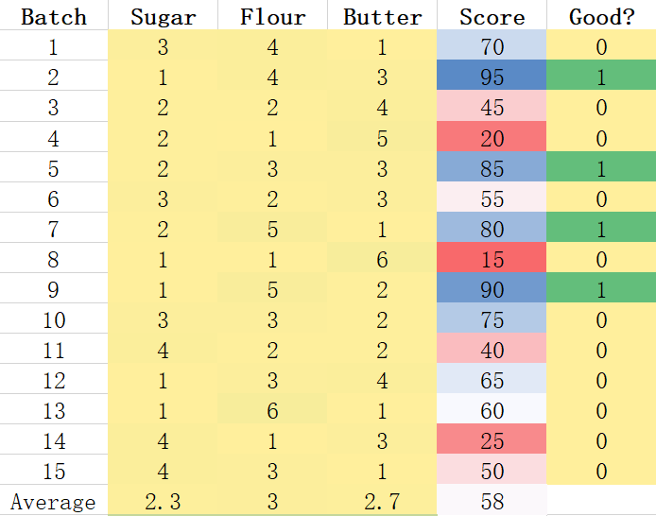

1. Calculating the distances among trials and samples in the three variables.

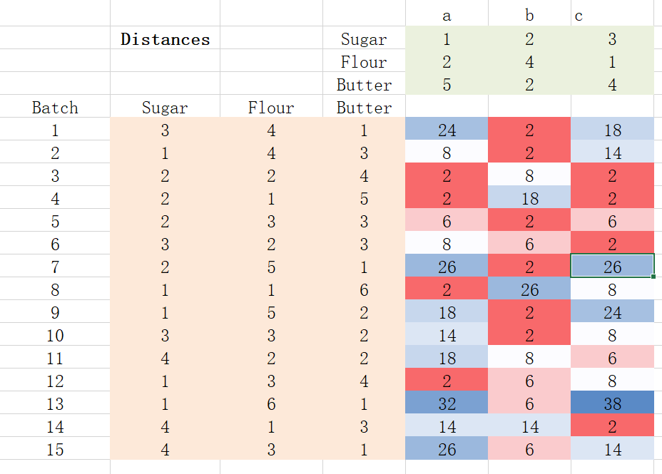

1. Ranking of distance

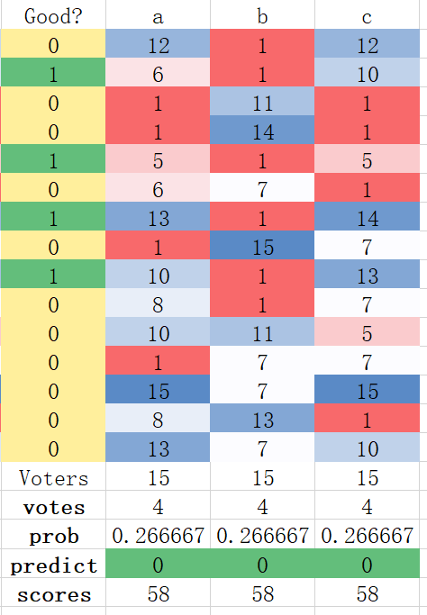

1. To estimate for each test recipe both the (i) score and (ii) probability of being good

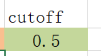

K=4

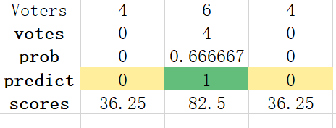

K=8

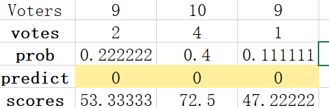

K=15

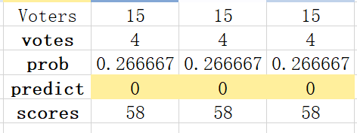

So, the b recipe seems better.

As the k increases, the probabilities and the scores of a, b, c are

